Social media marketing campaign

Own and run a business as one IT company which provides services on web like digital marketing, web development, software development and graphic design. I need to increase awareness for new company/services and find clients to meet the quarterly target with my marketing campaign. Things to highlight about company is reasonable prices for quality services.

The major components of this campaign are:

1. **Assembling a team:** A successful marketing team requires dynamic personalities and complementary skillsets to blend traditional marketing principles with new media strategies.

A marketing team with at least the following players or skillsets:

## Team Leader (Strategist and Analyst)

## Public Relations Person

## Advertising/Web developer (Innovator)

### Social Media Manager

### Copywriting person

### Image result for teams

### 2. Objectives: Get more clients and make more money. Target to get and maintain 3 big clients every month.

### C:\Users\760572\Desktop\some-images\objective.jpg

**3.** **Connective goals to objectives:**

1. Influencer Marketing Goals- 

-Make a website with all information

-Awareness (about company and services)

-More connections (networking)

-Increase awareness of available prices and discounts

b) Social Media Goals- ☺

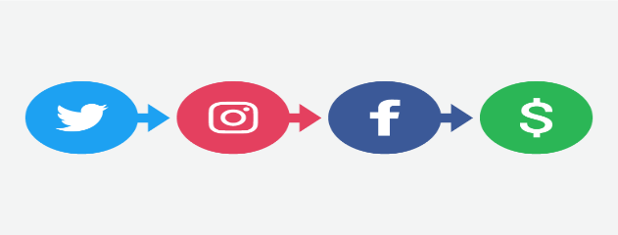

-Accounts on major social networks (Facebook, Twitter, LinkedIn, Instagram)

-Encourage social sharing of services and prices/discount.

-Share the content regularly and get feedback in posts/comments.

-Take decisions to upgrade the services after social media discussion.

-Introduce new products, new big assets of company, conduct surveys and contests to active our audience.

**4.** **Metrics/KPIs**

Social Media Metrics:

-No. of likes/posts/share

-No. of followers/fans

-Types of comments:

Consider these to take further decisions to make business better

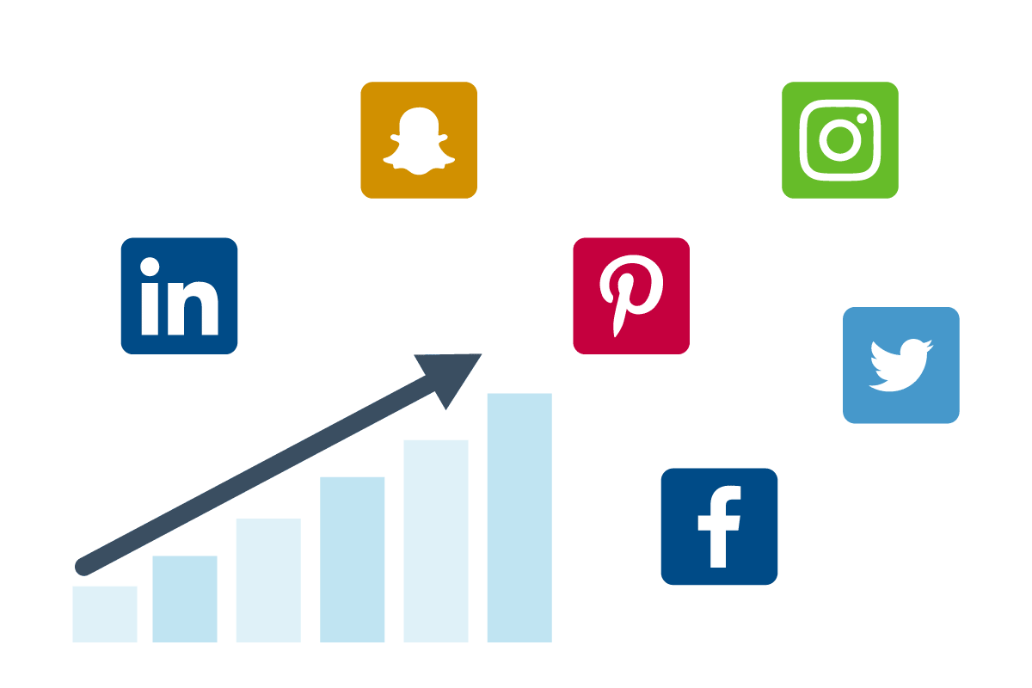

Website Metrics:

-No. of visitors

-Bounce rate

-Engagement rate

-Website traffic

-Search Engine Optimization

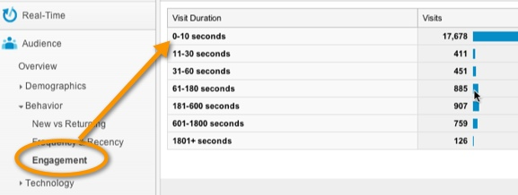

KPIs:

-No. of clients/month (from website/social media)

-Revenue growth rate

-Client satisfaction index

-No. of returning clients

-Market growth rate

-How many use the discount from social media

**5. Target Audience:**

-Local/global businesses who want online presence

-Small/big businesses who want to improve their online services (add ecommerce feature

-Whoever wants to make applications/websites, graphic design?

-Government markets (to make their old websites responsive)

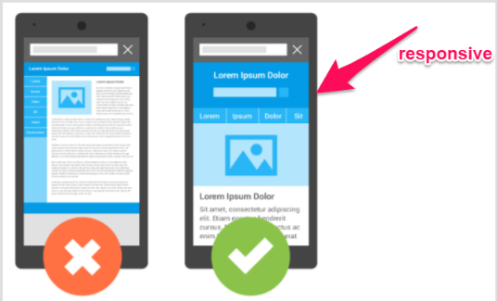

**6. Tactics**

### Social Media:

### -Share the link of website (showcase the work)

### -Share and tag the achievements

### -Tag key people and places (to increase SEO)

### -Share/tweet photos and videos with big named clients

### -Update blogs/posts on regular basis

### -Run seasonal promotion strategy (give some extra service to client in Christmas season)

### -Conduct surveys to be active in market

### -Coupon/contest sharing on social media to get extra

### -Paid advertisements

### Image result for website social media icons

### Content Management (on website)

### -Carefully check the content (images, videos, contact information)

### -Check quality of our product/services

### -Use pixel code to link with social media

### Networking

### -Meetups with technical people

### -Join IT groups to market my company

### Image result for meetups networking

### Trends

### -Will follow the trends (podcasts, subscription)

### -Increase the quality of product

### Google Analytics

### -Set up account and link the website

### -Free of charge

### Image result for google analytics logo

### SEO

### -Include factors (keywords, links, heading, good URL) in website design and in blog post

### -Technical staff will work on reduce the load time

### Image result for SEO

### 

### 7. Tracking

### 

### Google Analytics:

### -Set UTM parameters in campaign URL

### -Track the website traffic (where, when, engage time etc.)

### -Focus on target market according to location

### -Focus on particular business market needs

### Social Image:

### -Use social metrics to check the market image

### -How bigger the network (networking events / month)

### Number of clients:

### -How many new clients we have in end of month

### -How many potential clients contact us and have interest in our company

### Cash Flow:

### -How much money we make from client every month (same or more)

### Image result for cash flow

### 8. Workbacks /Budgets

### Following the schedule: Dated: Nov 30, 2018

### Launch the campaign

Description Date Who

1. Social Medias account setups 1 Dec Social media person

2. Website updates 1-2 Dec Web developer

(Add social media, google analytics)

3. Content management 3-7 Dec Team leader/team

(Blog posts, select images/videos)

4. Copy write the content 8-9 Dec Copy writer

5. Presence on social media 10 Dec Team

### 

### Brand Awareness (1 month plan)

### 

Description Date Who

1. Design advertisements 10-13 Dec Advertising Person

(to display discounts for first month)

2. Copy write the content 14 Dec Copywriter

2. Advertisements every day from 14 Dec Advertising Person

3. Publish Content 1 new content/ day Social media person

(Blog posts, share images/videos)

4. Case studies every day Team leader

(Know your audience, google analytics)

5. Track, analyze optimize every day Team leader

(Change the content/blog post accordingly)

6 Produce clear report of progress 30 Dec By everyone to Team leader

Budgets:

We have plan to spend $4000 to launch and promote the campaign initially.

Strategies for social media existence 10%

Design, graphics, visuals, content collection 30%

Paid advertisements 40%

Copy writing 10%

Tracking results 5%

Project Management 5%

Add $500 extra money in budget to give discounts for first month.

### 9. Analysis and Reporting

### 

### Web analysis:

### Google analytics reports – check the traffic, analyze the audience

### Number of visitors and average spending time on website

### Website contents are up to date and accurate to reach us

### Social media analysis:

### Social media dashboards/reports

### Number of people actively share us.

### Number of followers/fans on social media accounts

### Popularity of company

### Comments by clients

### Image result for reporting

Reports (Other than digital analytical reports)

Resource Output

Facebook 5 clients

Twitter 2 clients

LinkedIn 2 potential clients, 3 Trainees

Finance increased by 20%

Sponsors 2 sponsors



